# 1.Star Schema

1.1 Star Schema

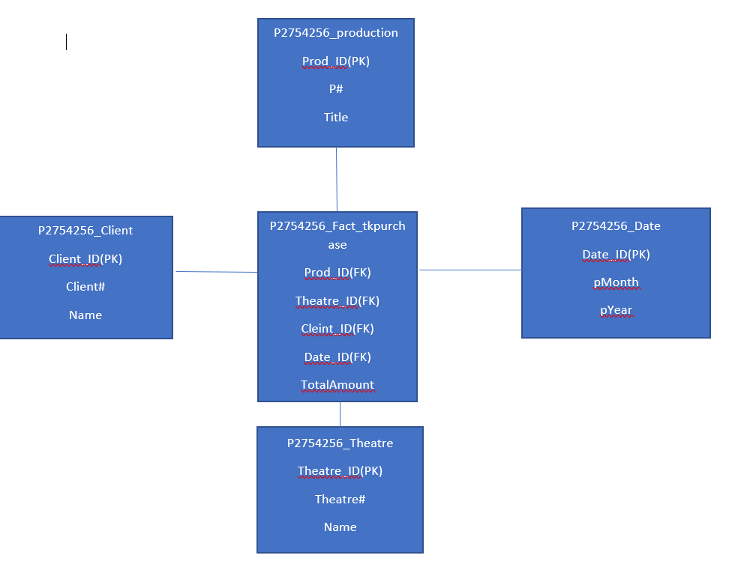

1.2 Explanation on Star Schema.

The Fact table consists of Prod_ID, Theatre_ID, Client_ID, Date_ID as the foreign keys from the dimensions that are taken into consideration as per the requirements of the data mart. Then there is TotalAmount for the aggregation, which is being used to find the requirements in respect to the total amount. While the dimensions are P2754256_Theatre from which we can get the theatre id and their names. P2754256_client from which we can get the client id their client number in the relational database and their name. P2754256_production from which the production number and is taken. Which also provides the name of the corresponding productions. Lastly there is P2754256_Date from which the monthly combined with yearly outcomes can be driven.

**Granularity: For each row in fact table the granularity is defined as the month wise spendings by the client on one production in particular theatre.**

## 2. Logical Relationship

P2754256_Production (Prod_ID,P#,Title)

P2754256_Theatre (Theatre_ID,Theatre#,Name)

P2754256_Client (Client_ID,Client#,Name)

P2754256_Date (Date_ID,pDate)

P2754256_Fact_tkpurchase (Prod_ID,Theatre_ID,Client_ID,Date_ID,Total Amount)

Theatre_Id is a foreign key referring to Theatre, Client ID is the foreign key referring to Client, while Prod_ID is the foreign key referring to the production. Lastly Date_ID is the foreign key referring to the Date in the fact table.

However, Prod_id is the Primary Key (PK) for P2754256_Production. Client_ID is the PK for P2754256_Client. Theatre_ID is the PK for P2754256_Theatre. Lastly Date_ID is the pk for P2754256_Date.

### 3.Creation of Tables

CREATE TABLE P2754256_date (

date_id number(5) PRIMARY KEY,

pYear number(4) NOT NULL,

pMonth number(2) NOT NULL);

CREATE TABLE P2754256_theatre (

theatre_id number(5) PRIMARY KEY,

Theatre# number(5) NOT NULL,

Name VARCHAR2(20) NOT NULL);

CREATE TABLE P2754256_client (

client_id number(5) PRIMARY KEY,

Client# number(5) NOT NULL,

Name VARCHAR2(30) NOT NULL);

CREATE TABLE p2754256_fact_tkpurchase(

Prod_ID number(5) CONSTRAINT fkprod REFERENCES p2754256_production,

Theatre_ID number(5) CONSTRAINT fktheatre REFERENCES p2754256_Theatre,

Client_ID number(5) CONSTRAINT fkclient REFERENCES p2754256_Client,

Date_ID number(5) CONSTRAINT fkdate REFERENCES p2754256_Date,

Totalamount number(*,22),

constraint pk_fact_tkpurchase primary key (Prod_ID,Theatre_ID,Client_ID,Date_ID));

CREATE TABLE p2754256_production(

prod_id number(5) primary key,

P# number(5) not null,

title varchar(20) not null);

#### 4. Data Source Identification, Data Extraction, Transformation, and loading

insert into P2754256_client select client.nextval, Client#, Name from

(select distinct c.Client#, upper(trim(c.Name)) Name from ops$yyang00.client c, ops$yyang00.ticketpurchase tp

Where c.Client#=tp.Client#)

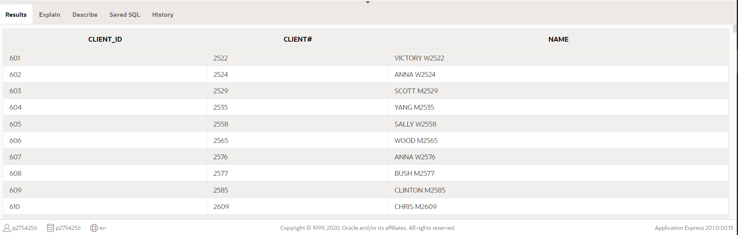

insert into P2754256_theatre select theatre.nextval, Theatre#, Name from

(select distinct Theatre#, upper(trim(Name)) Name from

(select t.Theatre#, t.Name

From ops$yyang00.Theatre t, ops$yyang00.Performance pr , ops$yyang00.ticketpurchase tp

Where t.Theatre#=pr.Theatre# and pr.Per#=tp.Per#));

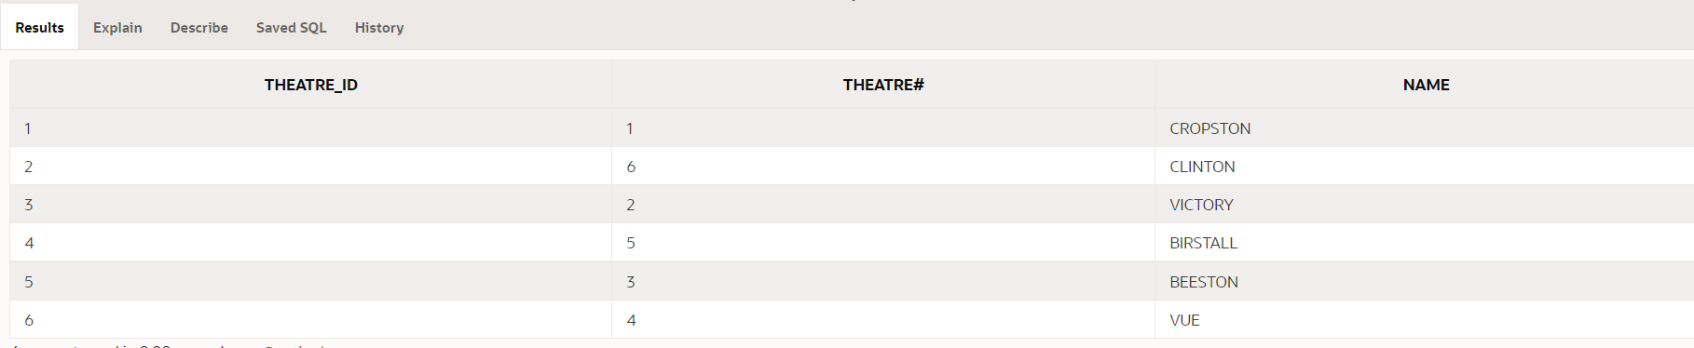

insert into P2754256_date select date_seq.nextval, year, month from

(select distinct extract(year from pDate) year, extract(month from

pDate) month

From ops$yyang00.Performance pr , ops$yyang00.ticketpurchase tp

Where pr.Per#=tp.Per#);

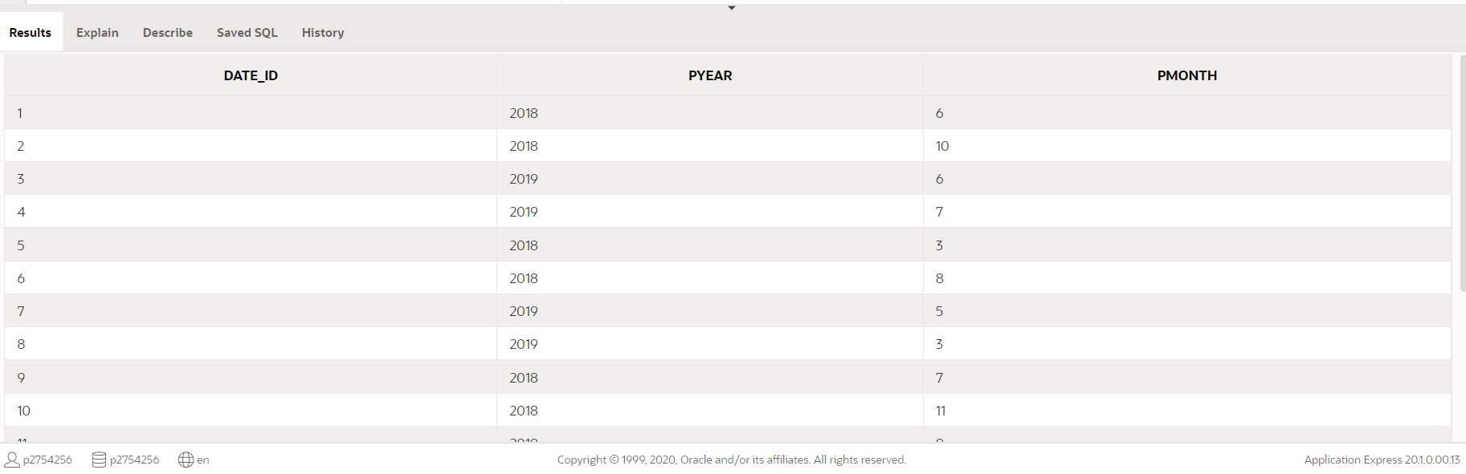

insert into p2754256_fact_tkpurchase select Prod_ID, Theatre_ID, Client_ID, Date_ID, Totalamount from

(select dp.Prod_ID, dt.Theatre_ID, dc.Client_ID, dd.Date_ID, sum(tp.Totalamount) Totalamount

from ops$yyang00.TicketPurchase tp, ops$yyang00.Client c, ops$yyang00.Theatre t,ops$yyang00.Performance p, p2754256_production dp, p2754256_Theatre dt, p2754256_Client dc, p2754256_Date dd

Where tp.Client#=c.Client# and tp.Per#=p.Per# and p.P#=dp.P# and p.Theatre#=dt.Theatre# and extract(year from p.pDate)=dd.pYear and extract(month from p.pDate)=dd.pMonth

Group by dp.Prod_ID, dt.Theatre_ID, dc.Client_ID, dd.Date_ID);

insert into P2754256_production select production.nextval, p#, title from

(select distinct p#, upper(trim(title)) title from

(select p.p#, p.title

From ops$yyang00.production p, ops$yyang00.performance pr, ops$yyang00.ticketpurchase tp

Where p.p#=pr.p# and pr.per#=tp.per#));

